Copeland Canoe Club

10th Ravenglass Seaquest

Sunday 5th June 2016

Start 1045am HW 1206 8.5m

A navigation event on the 3 beautiful estuaries at Ravenglass

Competitors, in kayaks or canoes, visit as many controls as they can, in the time limit of 3 hours.
An event for everyone, take your time and enjoy lunch alongside the Esk, or set yourself a challenge and join the competitive racers. A wonderful day out on the water however you choose to join us.
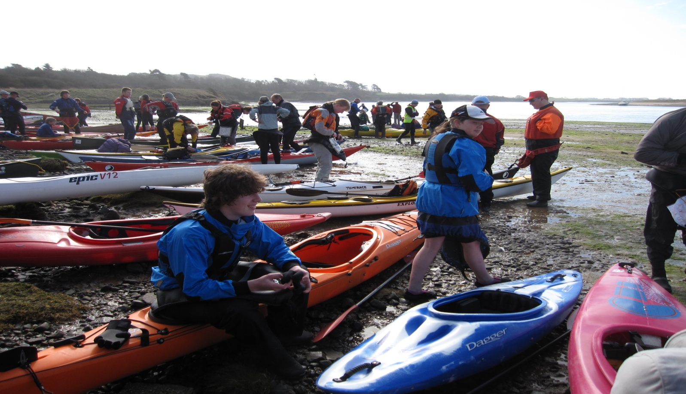

Entry fees for 2016 are £7 single: £4 Under 16: £15 per family

For entry forms and more information, please visit the CopelandCanoe Club website:
www.copelandcanoe.org.uk

